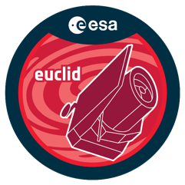

Euclid Early Release Observations Proposal
  - Proposal Title
Date of submission
Program Scientist name, affiliation, e-mail address
Scientific Collaborators name, affiliation, e-mail address
Scientific Collaborators name, affiliation, e-mail address

- Communication and outreach program
  - Envisaged communications narrative, how do objects relate to Euclid capability / mission objective? [max. 1/2 page]
Write here
  - What is the communications merit of the proposed astronomical object(s)?
Write here
  - Euclid products required (imaging and/or spectroscopy, NISP filters)
Write here
    - SGS Level 2 products identified from data model
Write here
    - Customized products, processing and calibration steps involved; development resources needed
Write here
  - Additional communication product ideas (special graphics efforts needed, video footage, animation, enhanced visual effects or filters on Euclid data etc.). If applicable, provide a simple sketch.
Write here

- Scientific Justification
  - Scientific rationale, immediate objectives and uniqueness of required Euclid capabilities to achieve the science goal [max. 1 page]
Write here
  - Identify risks related to limited early calibration performances
Write here
  - Data exploitation and validation plan for products identified for public releases and scientific analysis
Write here
  - Is there an immediate science result that can be released in the press-kit based on an early data processing?
Write here
- Example target list for ERO observing program
Name or other designation or generic description of object class | Right ascension and declination (J2000) | Pointing layout (single ROS pointing or area to be covered with adjacent fields or dither pattern) | If repetitions are needed (for increased sampling or depth) | If target is covered by existing PV implementation procedures (CALBLOCK-PV-ID)

- Any other material that will help the Program Committee to evaluate your suggestion
Write here

