Title of your abstract
Author #1¹, Author #2² and Author #3³.
¹ Affiliation 1. ²Affiliation 2. ³ Affiliation 3.
--- 400 words from here --- (please delete this line)
Lorem ipsum dolor sit amet, consectetur adipiscing elit. Donec nec fermentum augue. Integer id neque sit amet augue lacinia fringilla. Donec leo ipsum, dapibus vel orci et, viverra viverra sem. Morbi maximus neque ipsum, in vulputate libero porta a. Interdum et malesuada fames ac ante ipsum primis in faucibus. Nulla at libero arcu.
--- 400 words up to here --- (please delete this line)

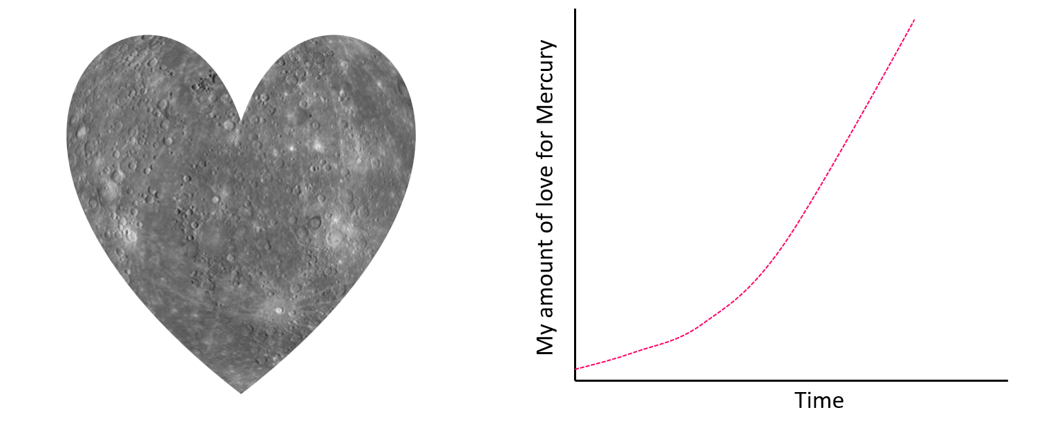

Figure 1: Mercury’s heart shape (left). The love for Mercury over the years.

