Student’s guide
CESAR Science Case – The differential rotation of the Sun and its Chromosphere

Name Date
_____________________________ ______________________
Introduction
The Sun as you may already know, is not a solid body. It is a massive body of gas constantly active. Even if we cannot see it, it is concluded by observations that the Sun rotates at different velocities depending on where you are looking at. The poles actually rotate slower than the equator, which is not obvious to our eyes but measurements and observations have concluded that.
There is also many different ways to observe the Sun. Some of its layers can only be observed from Earth using different types of telescopes such as the h-Alpha telescope that allows us to look at the chromosphere, the layer of the Sun where protuberances are visible. Other telescopes just reduce the incoming light of the Sun allowing us to observe the photosphere that is the Sun’s surface.
In the photosphere there are a huge amount of sunspots while a solar maximum occur. These sunspots are incredible big compared with human distances such as: a car, a house, a country.
In this laboratory, you are going to observe the Sun by taking images of it with different telescopes. The visual telescope will allow you to see how the Sun rotates at different velocities depending on the latitude. Using a h-Alpha telescope you are going to analyse the chromosphere trying to visualize its main structures such as: the protuberances, the filaments or the spicules.
Remember that if you want to observe the Sun by your own, you always have to use an appropriate filter, or project it on a screen.
Theoretical background
It was mentioned in the introduction that the Sun rotates at different velocities. The reason is because the Sun is not a solid body so the plasma and gases that are in constantly movement are not attached to anything and they are free to move anywhere. Convection movements below the surface and temperature differences push these masses to move faster in the equator and slower in the poles.
This particular rotation has very important consequences on the stars. For example it causes disturbance in its magnetic fields, causing the lines to “tangle”. This can be read in the CESAR Booklet for this Science Case, but here is a part from the booklet related to this topic:
It takes about 25 days around the equator compared to 35 days at higher altitudes. With the equator moving in a faster pace than the other areas of the Sun, the magnetic field lines will twist together over time. This will then produce loops in the magnetic field, which in turn will erupt from the surface of the Sun and create the formation of the Sun’s intense sunspots and other known solar events.
The easiest way to measure the Sun’s differential rotation is by tracking its sunspots. Sunspots at different latitudes will rotate at different velocities. But, what is exactly a sunspot? It was introduced in the booklet for this laboratory, but it is worth mentioning it here as well:
A sunspot is a region of the Sun that is disturbed by powerful magnetic fields. These magnetic fields avoid the natural movements of the material cooling the area. As the temperature decrease, it gets darker. Typically not only one sunspot is generated in the same area. The sunspots appear in groups of two, five or even more than twenty.
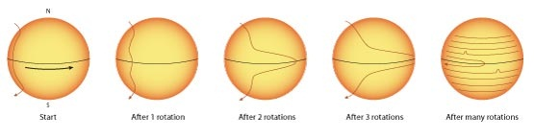Figure 1: The differential rotation of the Sun and the creation of sunspots Credit: NASA/IBEX
The sunspots can also be observed with an h-Alpha telescope but these telescopes are prepared to observe another details of the Sun, those that occur in the chromosphere. The chromosphere is a thicker layer than the photosphere and there is a huge amount of characteristics on it. To distinguish every structure of this layer, here is a short description for some of them:
- Prominences: they are one of the biggest structures from the Sun’s surface. They usually appear with a loop shape around the solar disk. That shape is produced by the magnetic lines that go outside the Sun’s surface. The material follows those lines so you could see the loop. Sometimes the loop is broken so what you see is just a mass ejection without any particular shape.
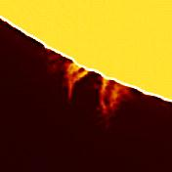
Credit: CESAR
- Filaments: a filament are prominences too, but viewed from a different perspective. A filament is against the Sun and appears darker while a prominence is viewed outside the solar disk. Some of them are not very long but others cover huge distances. As well as the prominences, they carry huge amount of material through the magnetic field lines.
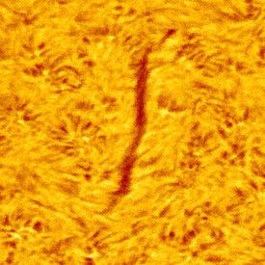
Credit: CESAR
- Spicules: a solar spicule is a jet of mass that moves upwards at a very high speed from the Sun’s surface. There are thousands of them on the chromosphere so they are very easy to observe as elongated structures very close ones from each other.
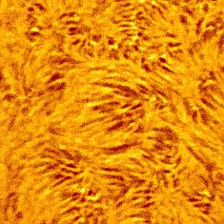
Credit: CESAR
- Plages: they are bright regions that appear near to the sunspots and they are usually bigger. They are typically associated with sunspot formation and also with concentrations of magnetic fields. They could also be observed without h-Alpha telescopes.
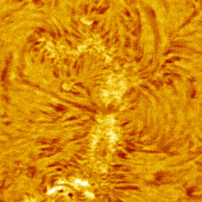
Credit: CESAR
- Micro flares (or Ellerman bombs): they are small flares that occur over the chromosphere. They appear as very brilliant dots on the surface. Through these flares, the Suns eject very high quantities of energy.
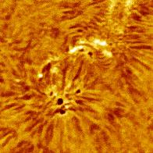
Credit: CESAR
Material
- CESAR Astronomical word list
- CESAR Booklet
- CESAR Formula sheet
- CESAR images of the Sun
- The software for this Science Case
- Paper, pencil, ruler, calculator, protractor
Laboratory description and purpose
The main purpose of this laboratory is to calculate the differential rotation of the Sun by observing it and recognise the main features of the solar chromosphere. For this, you are going to take images of the Sun with the CESAR Solar Observatory. To be able to estimate the differential rotation you need a reference frame, which are the sunspots. You need to see their movement; otherwise it is impossible to do any calculations. By taking images over a time period it is possible to see how they move over the surface. From 3 to 7 days are enough to see any movement.
It is important to know if there are any sunspots on the Sun before attempting to take images. Visit SOHO’s website and see the image of the Sun at the current date. If there are any sunspots present on the surface, then they probably will be there for the next days. The website for SOHO is http://sohowww.nascom.nasa.gov/sunspots/. Since the Sun is rotating around its own axis and its surface is constantly moving, the sunspots will obviously be at different locations each day.
Firstly you are going to do some measurements on the images to align them and once it has been done you are going to calculate the heliographic coordinates of at least two sunspots at different latitude to be able to appreciate the differential rotation. With this task you will see that is relative easy to learn about the structure of the Sun. Just attempting to the sunspots you will see that it is not a solid body and that it rotates at a very high rate considering its huge mass.
When you start with your calculations you can use whatever method you want, easy or a little more challenging one, it does not matter as long as you get a result that is reasonable and close to the real value.
We provide you the real value of the solar rate and also the rotation rate of all the rest of the planets so you could compare them attempting to their masses, volumes...
Finally using the h-Alpha images you should be able to recognize all the features on the chromosphere. It would be an easy task for you because you have an example for each feature in the “theoretical background” section. Take a look at all the images because some of these features may appear and disappear between each day. Furthermore, every feature may also appear with different sizes.
Laboratory execution
Start by reading the Booklet to understand the theory. By doing this, the laboratory will become much more easier to execute since you will have less questions and more understanding.
If your group has access to the Solar Observatory it is supposed that you have already choose a date for the beginning of the observation, and decided in how many days it will conclude. In the end, a start date and a finish date should be picked. An observation period of 3-7 days is a good example. It may seem to be many days but you will get a better visualization of all the Sun’s features.
Once you have the images of the Sun, it is time to start the measurements. You will need to write down the day and time the pictures you are using were taken and write down the position of the sunspots that appear on it. Follow your teacher instructions to first align the images and then calculate the heliographic coordinates of at least two sunspots at different latitudes as showed below. For example, two sunspots at 7 and 14 degrees is a good example; it doesn’t matter if the sunspots appear in different hemispheres, you just have to look at the absolute value of the latitude.
Date/time | Sunspot | Longitude(˚) | Latitude(˚) | Observations
17/11/14 – 12:00 | 1 | 242,813 | -18,209
17/11/14 – 12:00 | 2 | 246,745 | +12,699

Following the instructions included in the CESAR software for this Science Case you will be able to do all the measurements and you will also be able to align the images with a solar grid to easily determine the coordinates of any sunspot. Another way to do this is to plot the sunspots on a paper and use a protractor to project the Sun’s image on a board and then print the spots on a grid of the Sun, which your teacher is provided with if he consider this option.
When all the measurements have been done you have to calculate the angular velocity of the sunspots you choose. For this you just have to write down the longitudinal change in degrees for each pair of images and its corresponding time interval between each pair and all for each sunspot. Here is an example for the first one:
Sunspot 1 |  | Latitude 16
Pair | Longitude difference (˚) | Time difference (days)
1-2 | 12,325 | 0,987
2-3 | 12,380 | 0,991
… | … | …

Using the means of these values you should be able to calculate the angular velocity of each sunspot in units of degrees per day or degrees per second. As you know, you should appreciate the differential rotation of the Sun.
To compare these values with the angular velocity of other Solar System objects here is a table:
Planet's angular velocity
Planet | Velocity (˚/day)
Mercury | 6,14
Venus | 1,48
Earth | 360
Mars | 350,89
Jupiter | 870,53
Saturn | 818,96
Uranus | 501,16
Neptune | 536,27

Try to understand the whole concept behind this phenomenon and the calculations will be easy. Always ask your teacher for help.
Finally for the last task, you have to take the images that were taken by the h-Alpha telescope. Either if you use the CESAR software or not, you have to identify as much solar features as possible. If you use the software you will be asked for cataloguing each feature you found and a global summary will be automatically generated showing you all the prominences, filaments, and others that you recognized on the photos. Be careful and don’t count the same features twice.

